***AIM: PROJECT IMPLEMENTATION***



***MyHome - IoT Based Smart Home Automation System***

***Submitted to: Ms. Monali Rajput***

***Submitted by:***

***Narender Keswani(24)***

***Prathamesh Bhosale (10)***

***FYMCA-B***

**OVERALL DESIGN:**

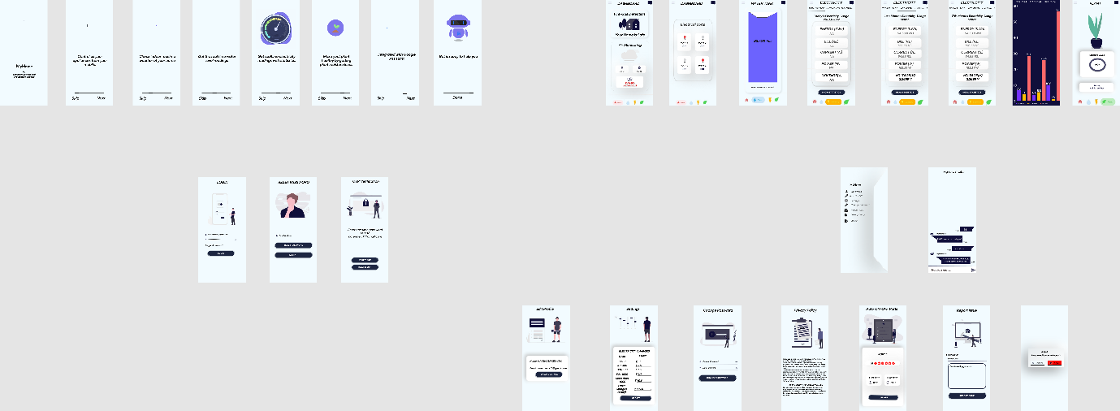

**FIGMA LINK:**

[**https://www.figma.com/file/8xxMRoQpFg0tkMnnrXHYWU/UI-UX-SMART-HOME-AUTOMATION-SYSTEM?node-id=0%3A1**](https://www.figma.com/file/8xxMRoQpFg0tkMnnrXHYWU/UI-UX-SMART-HOME-AUTOMATION-SYSTEM?node-id=0%3A1)

|  |  |  |  |  |  |
| --- | --- | --- | --- | --- | --- |
| **SPLASH SCREEN** | **ONBOARDING SCREEN-1** | | | | |
| **ONBOARDING SCREEN-2** | | **ONBOARDING SCREEN-3** | |
| **ONBOARDING SCREEN-4** | | | **ONBOARDING SCREEN-5** | |
| **ONBOARDING SCREEN-6** | | **ONBOARDING SCREEN-7** | |
| **LOGIN SCREEN** | | **OTP SCREEN** | |
| **RESET PASSWORD** | | **SIDE NAVIGATION BAR [MENU]** | |
| **DASHBOARD-1** | | **DASHBOARD-2** | |
| **WATER MONTORING SCREEN** | | **ELECTRICITY MONITORING SCREEN-1** | |
| **ELECTRICITY MONITORING SCREEN-2** | | **ELECTRICITY MONITORING SCREEN-3** | |
| **ELECTRICITY MONITORING SCREEN-4** | | **PLANT MONITORING SCREEN** | |
| **CHATBOT SCREEN** | | **EDIT PROFILE SCREEN** | |
| **SETTING SCREEN** | | **CHANGE PASSWORD SCREEN** | |
| **REPORT ISSUE SCREEN** | | **REPORT ISSUE SCREEN** | |
| **PRIVACY POLICY SCREEN** | | **LOGOUT SCREEN** | |

**CONCLUSION:**

Hence, the above displayed diagrams depict the overall User Interface designs of the Application and Implementation of the same.